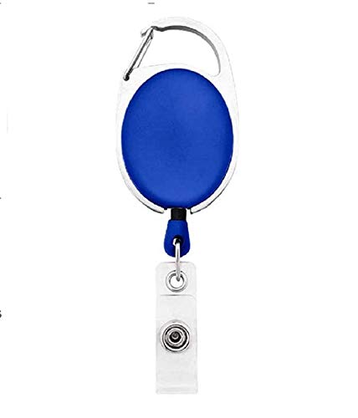



Henry Hunter | 
Marketing
02/15/2022
O +ve
12345678

Questions / Queries – Drop an email to mailmukeshkala@gmail.com

